**Creating Microservices for account and loan**

**Account Microservice**

Refer specification below:

Method: GET

Endpoint: /accounts/{number}

Sample Response. Just a dummy response without any backend connectivity.

{ number: "00987987973432", type: "savings", balance: 234343 }

**Answer:**

Generate Spring Boot Project:

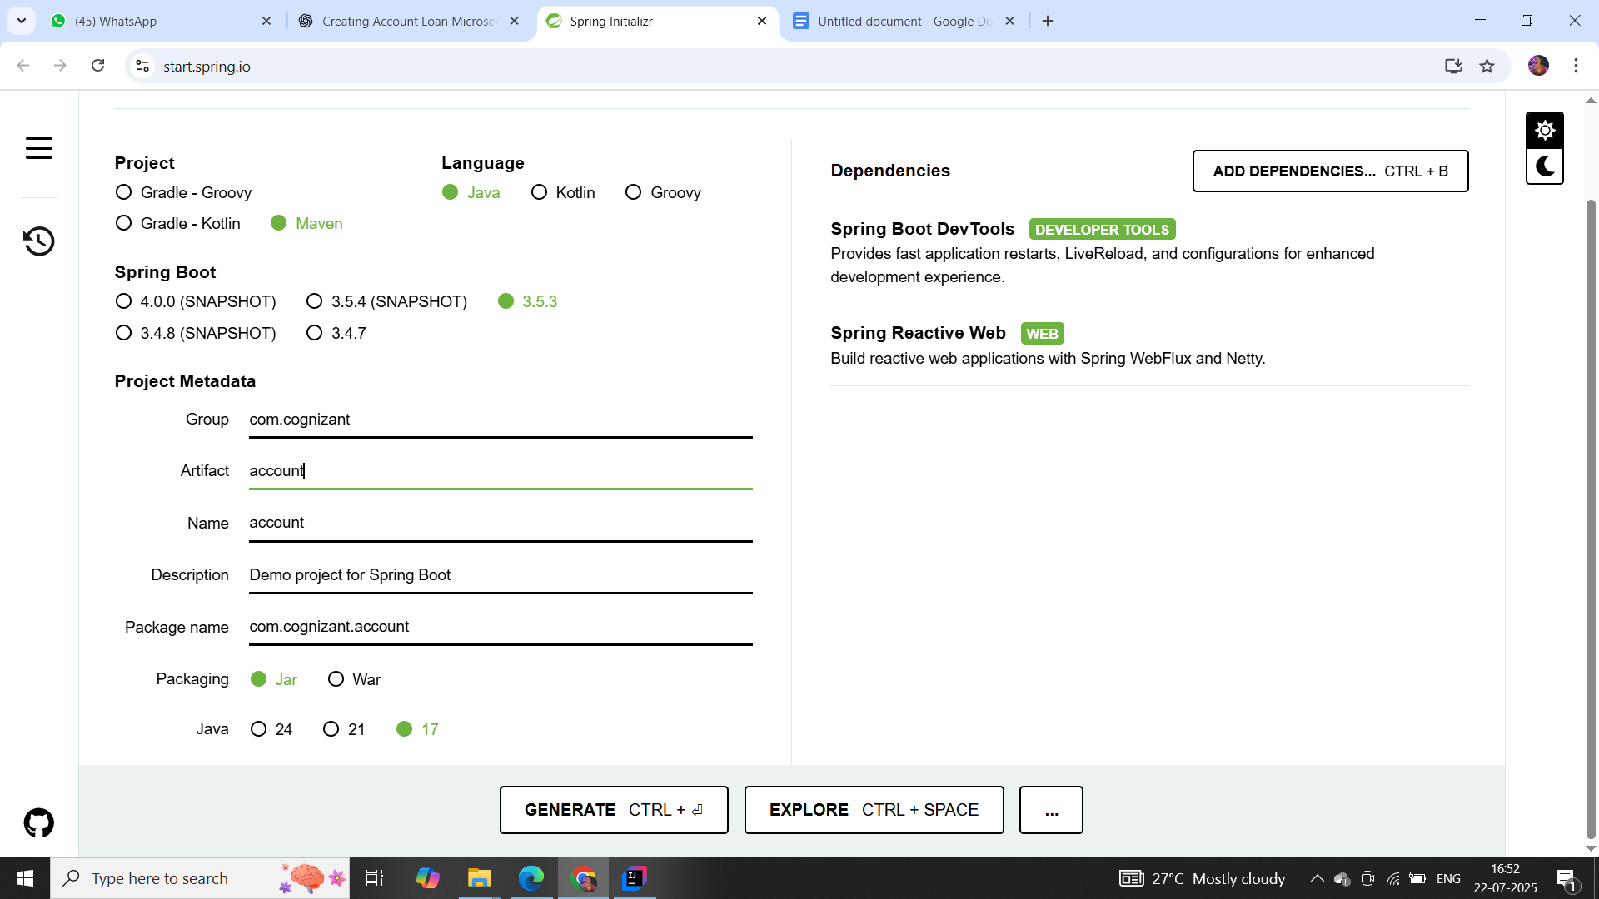

**AccountController.java**

package com.cognizant.account.controller;

import org.springframework.web.bind.annotation.GetMapping;

import org.springframework.web.bind.annotation.PathVariable;

import org.springframework.web.bind.annotation.RestController;

import java.util.Map;

@RestController

public class AccountController {

@GetMapping("/accounts/{number}")

public Map<String, Object> getAccountDetails(@PathVariable String number) {

return Map.of(

"number", number,

"type", "savings",

"balance", 234343

);

}

// Optional endpoint to test with just /accounts

@GetMapping("/accounts")

public Map<String, String> welcome() {

return Map.of("message", "Account Service is up and running!");

}

}

**AccountApplication.java**

package com.cognizant.account;

import org.springframework.boot.SpringApplication;

import org.springframework.boot.autoconfigure.SpringBootApplication;

@SpringBootApplication

public class AccountApplication {

public static void main(String[] args) {

SpringApplication.run(AccountApplication.class, args);

}

}

**pom.xml**

<project xmlns="http://maven.apache.org/POM/4.0.0"

xmlns:xsi="http://www.w3.org/2001/XMLSchema-instance"

xsi:schemaLocation="http://maven.apache.org/POM/4.0.0

http://maven.apache.org/xsd/maven-4.0.0.xsd">

<modelVersion>4.0.0</modelVersion>

<groupId>com.cognizant</groupId>

<artifactId>account</artifactId>

<version>0.0.1-SNAPSHOT</version>

<name>account</name>

<description>Account microservice</description>

<packaging>jar</packaging>

<parent>

<groupId>org.springframework.boot</groupId>

<artifactId>spring-boot-starter-parent</artifactId>

<version>3.2.4</version>

<relativePath/> <!-- lookup parent from repository -->

</parent>

<properties>

<java.version>17</java.version>

</properties>

<dependencies>

<!-- Spring Boot Web Starter -->

<dependency>

<groupId>org.springframework.boot</groupId>

<artifactId>spring-boot-starter-web</artifactId>

</dependency>

<!-- Optional: DevTools -->

<dependency>

<groupId>org.springframework.boot</groupId>

<artifactId>spring-boot-devtools</artifactId>

<scope>runtime</scope>

<optional>true</optional>

</dependency>

</dependencies>

<build>

<plugins>

<!-- Maven Compiler Plugin -->

<plugin>

<groupId>org.apache.maven.plugins</groupId>

<artifactId>maven-compiler-plugin</artifactId>

<version>3.8.1</version>

<configuration>

<source>17</source>

<target>17</target>

</configuration>

</plugin>

</plugins>

</build>

</project>

**Output:**

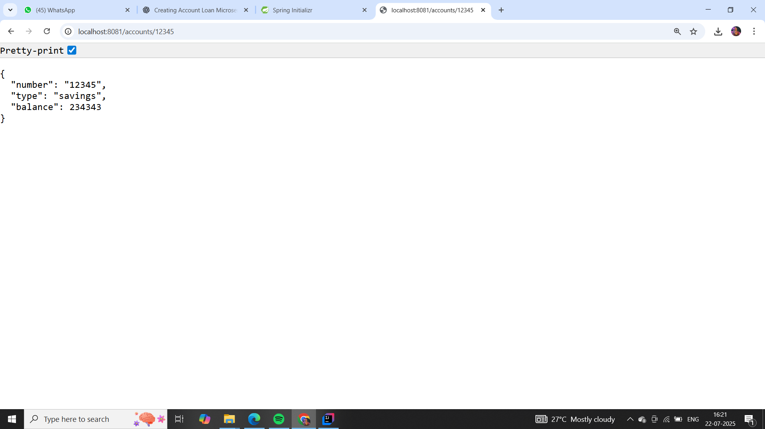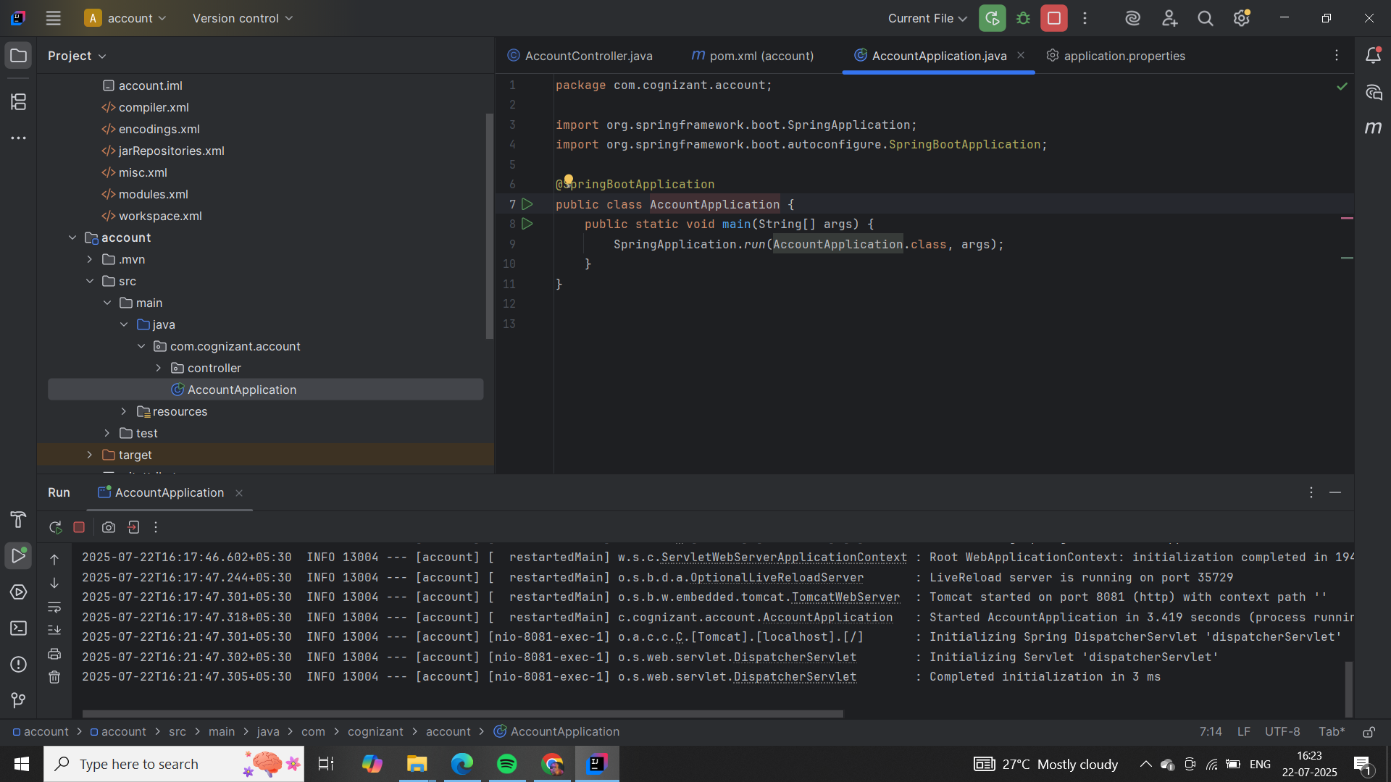

**Loan Microservice**

Follow similar steps specified for Account Microservice and implement a service API to get loan account details

Method: GET

Endpoint: /loans/{number}

Sample Response. Just a dummy response without any backend connectivity.

{ number: "H00987987972342", type: "car", loan: 400000, emi: 3258, tenure: 18 }

**Answer:**

Generate Spring Boot Project:

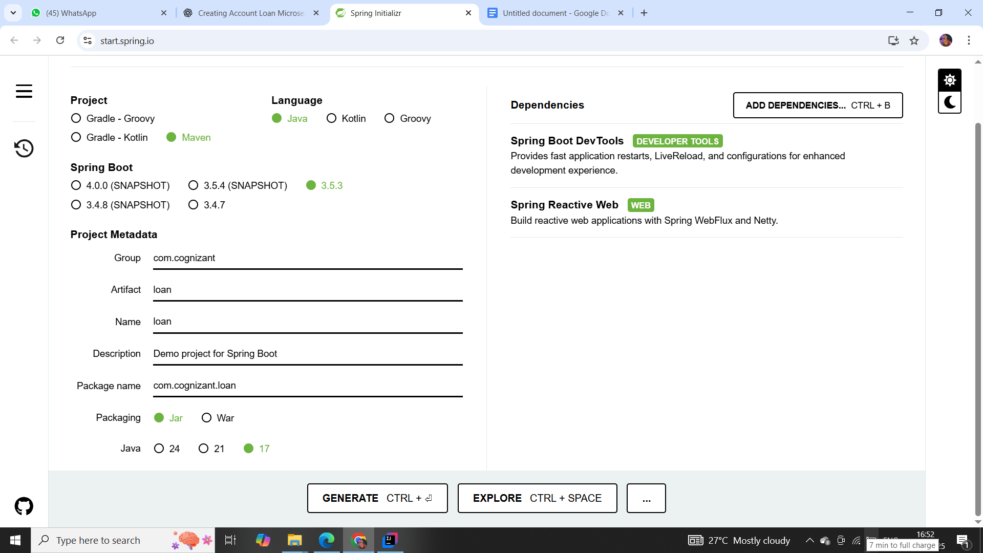

**LoanController.java**

package com.cognizant.loan.controller;

import org.springframework.web.bind.annotation.GetMapping;

import org.springframework.web.bind.annotation.PathVariable;

import org.springframework.web.bind.annotation.RestController;

import java.util.Map;

@RestController

public class LoanController {

@GetMapping("/loans/{number}")

public Map<String, Object> getLoanDetails(@PathVariable String number) {

return Map.of(

"number", number,

"type", "car",

"loan", 400000,

"emi", 3258,

"tenure", 18

);

}

@GetMapping("/loans")

public Map<String, String> welcome() {

return Map.of("message", "Loan Service is running!");

}

}

**Output:**

